25th June 2015

**YOKOHAMA supplements Line-up of “Exceed” High-Pressure Hoses for Global Market by Introducing New 42MPa Hose**

Tokyo ‒ The Yokohama Rubber Co., Ltd., announced today that it has further supplemented its line-up of “Exceed” brand high-pressure hoses sold on the global market for replacement hoses with the addition of a hose capable for use with pressures up to 42MPa (mega Pascal). The new 42MPa hose, launched in May, is available in five aperture diameters: 12mm, 15mm, 19mm, 25mm, and 50mm. The addition of the new series expands the Exceed product line-up to five series capable of handling a wide range of high-pressure specifications: 7MPa, 21MPa, 28MPa, 35MPa, and 42MPa.

The entire Exceed line-up is compliant with the ISO18752*\*1* international standard and is used mainly in high-pressure hydraulic equipment, especially construction equipment and industrial machinery. Since its launch in March 2009, the Exceed brand has been adopted by a growing number of users, especially in the United States, China, and Southeast Asia.

*\*1: An international standard for textile- and wire-reinforced rubber hoses created primarily by members of the Japan Rubber Hose Manufacturers Association, including Yokohama Rubber, and implemented in 2006. Taking into account users’ selection of hoses based on working pressure and aperture diameter, the standard classifies hoses according to working pressure.*

The newly developed 42MPa Exceed hoses are compliant with the ISO18752 standard’s impulse-resistance grade types*\*2* CS and CC for 500,000 cycles and DC for one million cycles. With the development of the 42MPa hoses, Yokohama Rubber has succeeded in increasing the usable life span of hoses subjected to repeated pressurization (i.e., impact pressure performance, an important indicator of hose performance) while keeping the minimum bending radius at the same level as that for the existing 35MPa series. As a result, the new 42MPa hoses can be used with the same pipe configurations as previous series.

*\*2: Grade types*

|  |  |  |  |  |  |
| --- | --- | --- | --- | --- | --- |
| *Size* | *12mm* | *15mm* | *19mm* | *25mm* | *50mm* |
| *Grade type* | *DC* | *DC* | *CS* | *CS* | *CC* |

Expecting further expansion of global demand for replacement high-pressure hoses, Yokohama Rubber intends to aggressively develop and market its Exceed brand. Leveraging a marketing network comprising industrial product sales subsidiaries in the United States, China, Singapore and Germany, the Company plans to expand the Exceed product line-up based on the needs of users in each target market.

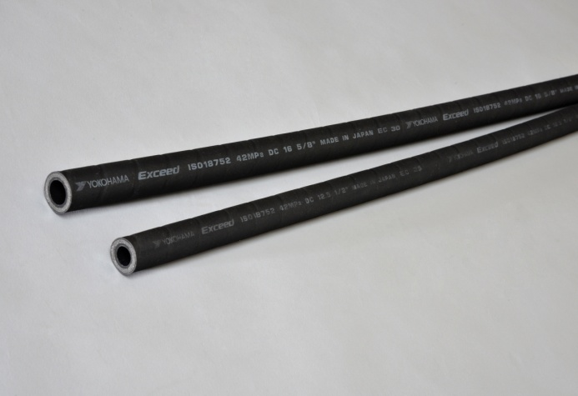

***“Exceed” hoses with maximum working pressure of 42MPa***